**Central Tendency (Mean, Median & Mode) Quantitive Analysis of Placement data**

**Screen-1 Placement Data**

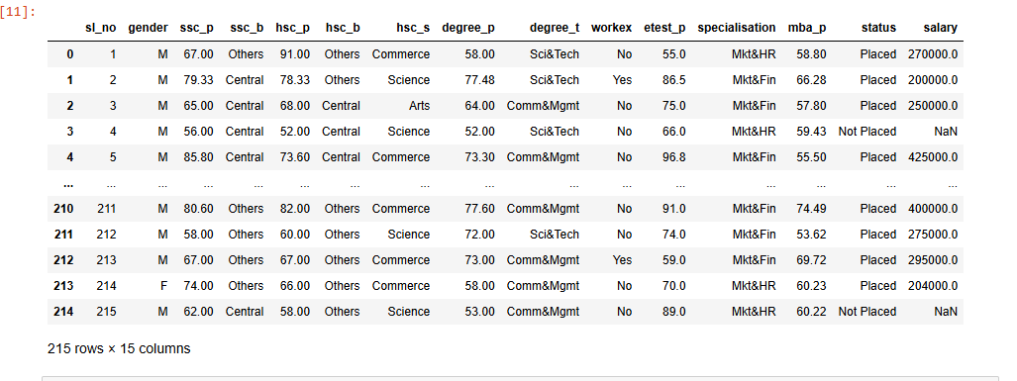

**Screen-2 – Quantitative Columns used for Placement Analysis**

**'sl_no', 'ssc_p', 'hsc_p', 'degree_p', 'etest_p', 'mba_p', 'salary'**

**Screen-3 Central_Tendency_Mean_Median_Mode_results**

**Mean –** Mean Includes if the data has outlier to calculate the average so the mean may be misleading if the data has outlier

**Median-** : Median looks at the middle of the dataset so if the data has outlier, median value will provide correct predicated value when compared to the mean value for the same data

**Mode -** Most often or Most Frequently (not the number of times) occurring value in the data.

**Outlier** : Cases that have data values that are very different from the data values for the majority of cases in the dataset

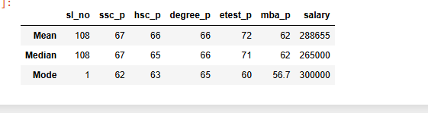

**Central_Tendency_Mean_Median_Mode_result Data Analysis**

**SSC_P:** Mean and Median score values are the same, students scored 67

Mode score value is 62 - Frequently occurring value

Inference Analysis: Mean and Mode score values are the same, so outliers data for this column is in the normal range (not too high or too low) – Students Scored Average

**HSC_P:** Mean (66) and Median (65) score values are the same.

Mode score value is 63 - Frequently occurring value

Inference Analysis: Mean and Mode score values are the same, so outliers data for this column is in the normal range (not too high or too low) – Students Scored Average

**DEGREE_P:** Mean and Median values are the same. Students scored 66

Mode is 65 - Frequently occurring value

Inference Analysis: Mean and Mode score values are the same, so the outliers data for this column is in the normal range (not too high or too low) – Students Scored Average.

**DEGREE_P:** Mean and Median score values are the same. Students scored 66

Mode is 65 - Frequently occurring value

Inference Analysis: Mean and Mode score values are the same, so the outliers data for this column is in the normal range (not too high or too low) – Students Scored Average

**ETEST_P:** Mean(72) and Median(71) score values are almost the same.

Mode is 60 - Frequently occurring value

Inference Analysis: Mean and Mode score values are the same, so the outliers’ data for this column is in the normal range (not too high or too low) – Students Scored Above Average.

**MBA_P:** Mean and Median score values are the same. Students scored 62

Mode is 56.7 - Frequently occurring value

Inference Analysis: Mean and Mode score values are the same, so the outliers’ data for this column is in the normal range (not too high or too low) – Students Scored Average

**SALARY:** Mean (2,88,655) and Median (2,65,000) score values are Not the same the difference is 23,655

Mode is 300,000 - Frequently occurring value

Inference Analysis: Mean and Mode score values are not the same, the outliers data – has some high level outlier values which is causing the difference in salary